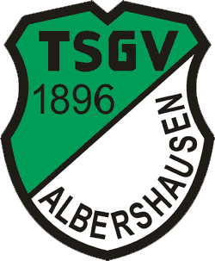

First Mäußnest Acro-Cup
13. - 16. April 2023
Sporthalle Albershausen
Schulstrasse 33
Germany

Please send the form to:
Organizing Committee / Host Federation
Sportakrobatik TSGV Albershausen
e-mail: acrocup@gmail.com

Deadline: 22. February 2023

travel schedule form

Federation |  | Contact person:
Federation |  | Phone:
Federation |  | E-mail:

If the team delegation is scheduled on more than one transportation mean, please complete one (1) form for each transportation mean. For earlier arrival or later departure please contact the OC.

Arrival information
Date: |  |  |  | Arrival time
By plane | Airport: |  | Flight # |  | From
By train | Station: |  | Train # |  | From
By bus | Station: |  | Bus # |  | From
By car

Departure information
Date: |  |  |  | Departure time
By plane | Airport: |  | Flight # |  | To
By train | Station: |  | Train # |  | To
By bus | Station: |  | Bus # |  | To
By car

Number of people for transportation: _______ people

Please fill it out with the computer and not by one's own hand. Thank you!

